10.1.1 [FusionC Specific Addition] Test Automation Concept Overview
IT Quality Assurance

Exported on 2026-05-15 05:31:42

Table of Contents

1 Objective 4
2 Mission & Vision 5
3 Overview of the framework - STAF 6
4 Types of Test Automation 7
5 Test Automation Architecture 8
6 10.1.1.1 [FusionC Specific Addition] Test Automation Structure & Approach 9
6.1 Test Automation Flow 9
6.2 Test Case Development Approach 10
6.2.1 TDD Test Driven Development (TDD) - 10
6.2.2 Behavioral Driven Development (BDD) - 10
6.2.3 Acceptance Test Driven Development (ATDD) - 10
6.3 Test Execution 11
6.4 Tooling Concept 11
6.4.1 Platform Vs Tools matrix 12
6.4.2 STAF - Features and Architecture 12
7 10.1.1.2 [FusionC Specific Addition] Team Specific deviations from FTC guidelines on Test Automation 14
7.1 Deviations 14

Page Details
Status | released 27-aug-24
Contact | Max Jung, Vodafone
Content of Page:
- Objective
- Mission & Vision
- Overview of the framework - STAF
- Types of Test Automation
- Test Automation Architecture

Objective
The Test Automation Concept strongly focuses on the "Shift left" approach. It enables teams to do early, iterative, and thorough testing, using the largest possible test automation at every test phase, running integrated within each CI/CD pipeline.
The Solstice Test Automation (STAF) is used across teams to perform test automation in Vodafone environments or CI/CD pipelines.

Mission & Vision
The test automation strategy follows the same principles regarding the mission and vision as described in the IT Test Strategy Chapter 1 "Introduction and general overview": https://de.confluence.agile.vodafone.com/x/jV19Cw

Overview of the framework - STAF
As per the high-level approach below are the features that test automation in FusionC should meet within teams.
- Teams that are using the STAF can keep track of the current STAF version on this release page (https://de.confluence.agile.vodafone.com/x/27OuBw ). This release page contains the latest updates of features and the applications within the STAF.
- The tests can be used for regression in a CI/CD, since they are based on Maven and thus ensure compatibility with pipelines.
- Test cases are Behavior-Driven (written in Gherkin format) and therefore easy to understand and adaptable to acceptance criteria.
- The tests can easily be reused by other teams.
- Source code is located in the VFDE-STAF :: Vodafone DE Solstice and is therefore available to all with appropriate authorization for adaptation.
- Automated update of test results into Jira/Xray.
- Monitoring of the test progress is possible.
- STAF supports parallel test execution to reduce overall test execution time.
- To increase the usability and understandability of STAF, this documentation has been created. https://de.confluence.agile.vodafone.com/x/EF-IGQ

The diagram below explains in detail STAF's(Solstice Test Automation Framework) technical working system, connected application and integration- test repositories, CI connections, and compatible environments. For STAF usage and other technical details, the User Manual page can be referred to: https://de.confluence.agile.vodafone.com/x/C4SoAw

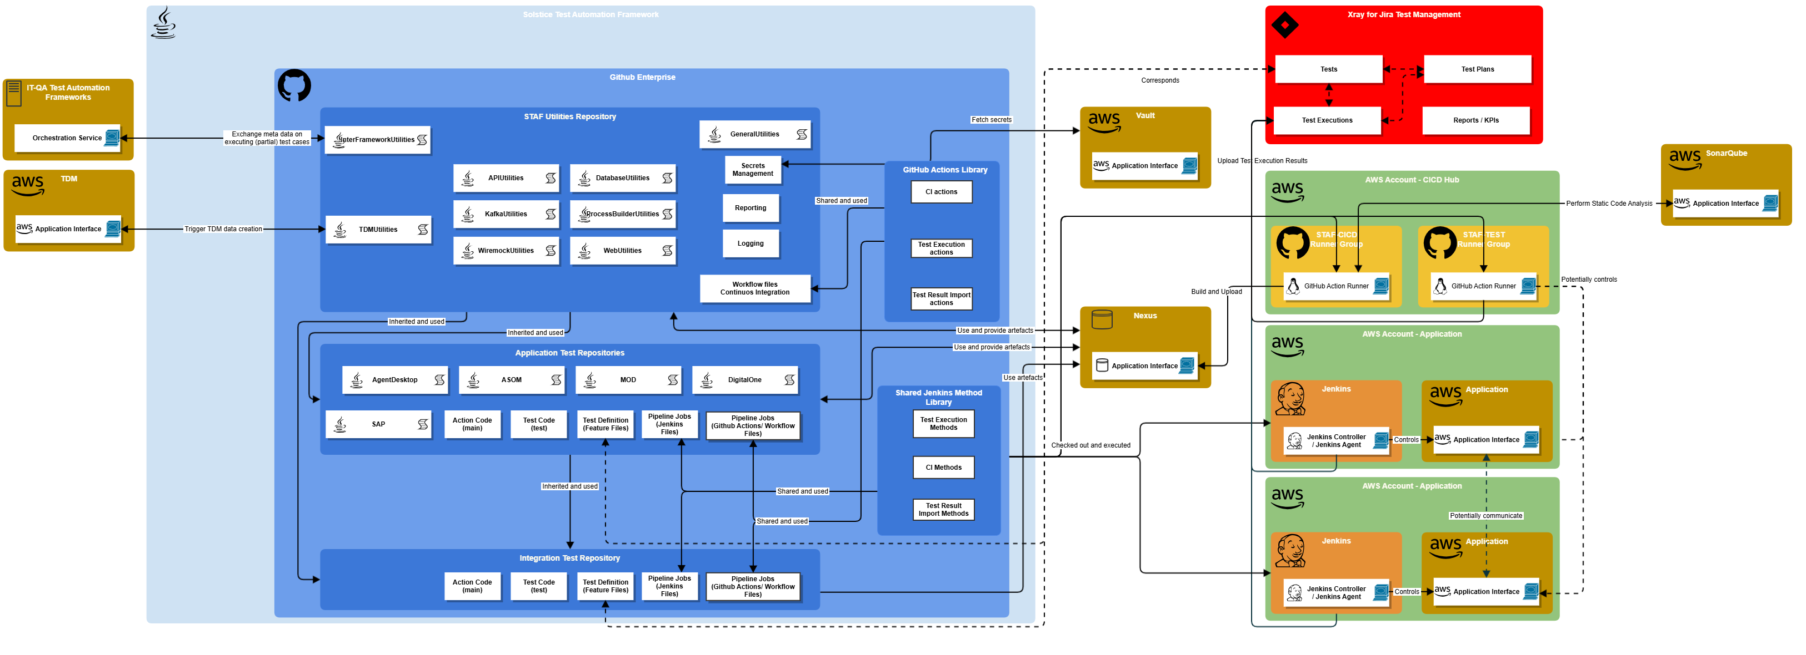

Types of Test Automation
Test Automation can be applied to any of the test phases that are listed in the IT Test Strategy in Chapter: Test Stages and Test Domains

Test Automation Architecture
For details on the Architecture check out the Test Architecture in this sub-page

Related Pages:
- STAF User Manual
- TA Enablement Guideline

10.1.1.1 [FusionC Specific Addition] Test Automation Structure & Approach
Page Details
Status | released
Contact | Max Jung, Vodafone
Content of Page:
- Test Automation Flow
- Test Case Development Approach
  - TDD Test Driven Development (TDD) -
  - Behavioral Driven Development (BDD) -
  - Acceptance Test Driven Development (ATDD) -
- Test Execution
- Tooling Concept
  - Platform Vs Tools matrix
  - STAF - Features and Architecture

Test Automation Flow
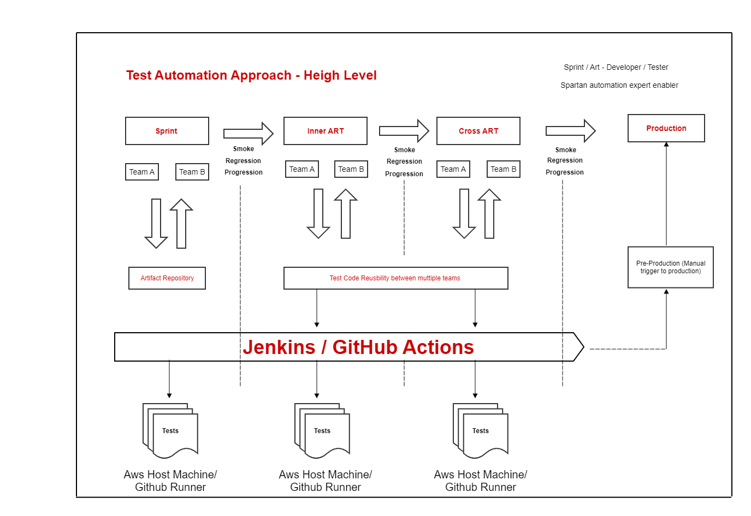

Step | Action
1 | Jenkins/GitHub Actions will trigger unit test cases pack execution in docker containers in AWS host machine and GitHub Runner respectively.
2 | Upon successful execution of unit test cases, application will be deployed in team's environment for System testing.
3 | After successful application deployment, system test cases pack will be triggered in docker containers in AWS in Teams environment (for Amdocs Teams it will be triggered in Amdocs environment).
4 | Upon successful execution of system test cases, application will be deployed in program environment for inner-ART testing.
5 | After successful application deployment, inner-ART test cases pack will be triggered in docker containers in AWS in Program environment.
6 | Upon successful execution of inner-ART test cases, application will be deployed in Solution environment for cross-ART testing.
7 | After successful of application deployment, cross ART test cases will be triggered in docker containers in AWS in Solution environment.
8 | On demand, manual trigger of application deployment will happen in Pre-prod and Prod environment

Test Case Development Approach
Currently, various approaches are available for developing test cases. Please refer to the Confluence page mentioned below for a comprehensive understanding of these methods.
Development Strategies for a better Quality

TDD Test Driven Development (TDD) -
For a better understanding of TDD, kindly refer to the Confluence page url provided below. TDD is optional for team.
https://de.confluence.agile.vodafone.com/x/naXACw

Behavioral Driven Development (BDD) -
BDD is mandatory for STAF. For a better understanding of BDD, kindly refer to the Confluence page url provided below.
https://de.confluence.agile.vodafone.com/x/d67ACw

Acceptance Test Driven Development (ATDD) -
For a better understanding of ATDD, kindly refer to the Confluence page url provided below. ATDD is optional for team.
https://de.confluence.agile.vodafone.com/x/rMriCw

Test Execution
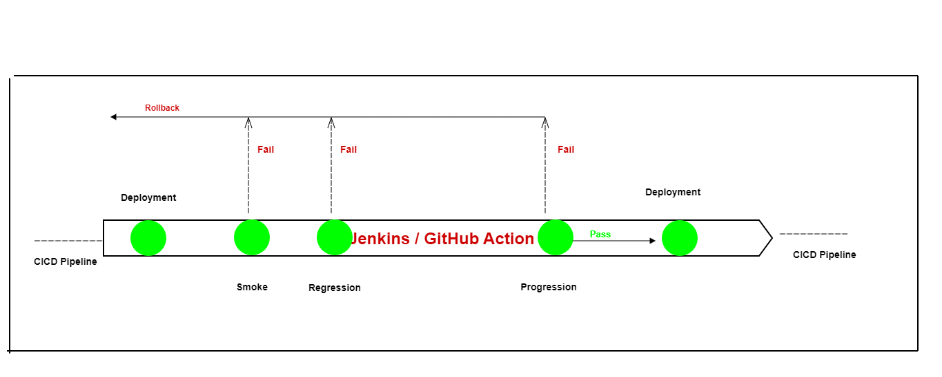

- Test case will get executed as per above CI/CD pipeline using Jenkins or GitHub Actions.
- Automation test expert is responsible for choosing the right tests for Smoke and Regression pack as per planned changes in sprint.
- Results will be updated automated in x-ray with all execution details. Kindly find below is a sample x-ray test report.
- Test execution list should get created for each test run in x-ray.
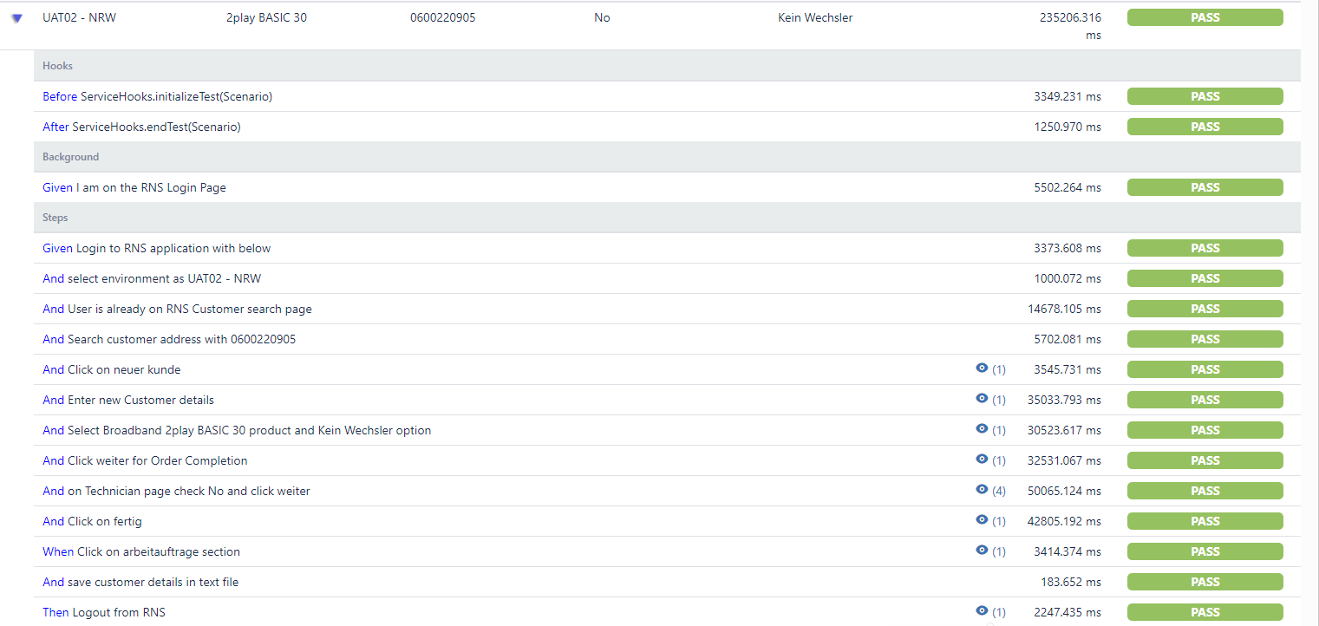

Tooling Concept
Solstice test automation tooling concept is based on below points.
- Application platform (Amdocs, SAP, etc.) involved in delivering the overall solution.
- Easy adaptation to CI/CD pipeline architecture.
- Re-usability of tools and test cases across ART/CROSS-ART teams.
- Feasibility of performing all types of testing Unit/System/Integration testing.

Platform Vs Tools matrix
Web | Yes | Cucumber & Selenium WebDriver
API | Yes | RestAssured
Database | Yes | JDBC
Mobile | No | -
SAP | Yes | Tosca*
SAP GUI | Yes | Cucumber & Selenium WebDriver

- *Licensed software
- Rest all are open-source software.
For legacy system, still to see the automation feasibility aspect.

Others | Tools
Code Repository | - GitHub
Test Dev Env (Exemplary) | - IntelliJ Idea  - Git Client  - JDK
Build tool (Exemplary) | - Maven
Test Management | - X-ray
Build/Orchestration | - GitHub Actions  - Jenkins

STAF - Features and Architecture
Features -
- BDD (Behavior driven development) is based on test automation framework.
- Compatible with synchronization of execution results to x-ray.
- Compatible to re-use existing test cases from TestNG framework (Amdocs).
- Test case execution compatible in continuous integration with CD pipeline.
- Test automation types supported (team is continuously enhancing support platform as per need)
  - Web front-end automation (GUI Automation)
  - Database test automation
  - Command line/Unix command automation
  - API Automation
- Features/scenarios managed in separate folders from multiple teams to avoid complexity but common utilities availability for all from all.
- GitHub Action Templates such as
  - STAF Artifact Creation Template
  - STAF CI Job Template
  - STAF Test Execution Template

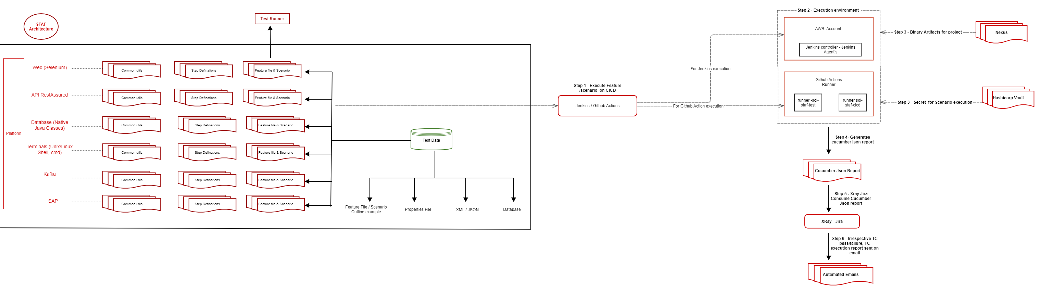

Related Pages:
- Test Reports

10.1.1.2 [FusionC Specific Addition] Team Specific deviations from FTC guidelines on Test Automation
Page Details
Status | released
Contact | Max Jung, Vodafone
Content of Page:
- Deviations

Deviations
In some cases there might be reasons deviate from FTC guidance and program expectations regarding test automation. If so, it needs to be clearly documented:
- Reason for deviation/exception
- Description of the deviation/exception
- Summary on who took the decision for deviation/exception and when

 | Affected Application | Affected Teams | Reason why FTC guidelines can not be followed | Description of the exception | Exception approved by ... | Exception approved on ...
1 | SAP OneAR non-productive environments (DRM, QRM, XRM and ARM) | BlackHawk | Tosca as a SAP certified tool is optimized for test automation in SAP. With manageable human effort, different test scenarios can be fetched and re-used for later regression test scenarios. | Tosca is a SAP certified test automation tool for SAP environments. It is also used for test automation in other Vodafone SAP environments.  After intense tool evaluation, Tosca has been chosen as test automation tool for SAP OneAR.  In the parallel SAP-projects by VF-Group (e.g. SAP RISE) it is as well decided that Tosca is the dedicated tool for SAP test automation. In order not to break the "OneAR" scope, it is therefore requested not to break the tooling guidelines.  The exception limited to System Test in BlackHawk.  Integration test is committed to be performed with STAF.  BlackHawk will collaborate and sync with e2e Bugxxx teams for test step and further support on test scenarios.  One-up-down IF-test will be considered.  X-Ray needs to be used for regression test documentation. | Unknown User (martina.riedel@vodafone.com) | 04 Oct 2024

Related Pages:

